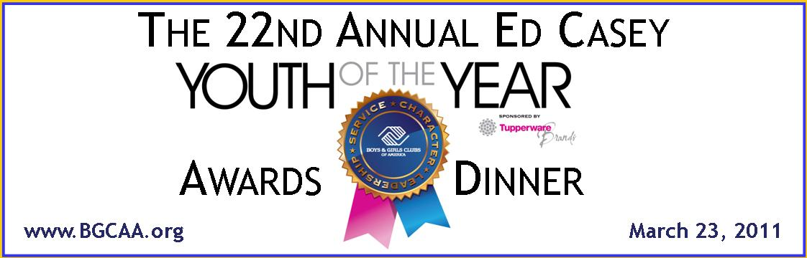

JOIN US IN HONORING OUR INCREDIBLE YOUTH!

Join us in supporting the Boys & Girls Clubs of Annapolis & Anne Arundel County by sponsoring the Ed Casey Youth of the Year Awards Dinner. The dinner will be held at the Boys & Girls Club at Bates Heritage Park in Annapolis on Wednesday, March 23, 2011. This year’s dinner will be preceded by a VIP cocktail reception with Coach Frank Beamer from Virginia Tech.

Many of our most esteemed community leaders and business associates will be in attendance to honor our youth. Be a part of the celebration by giving your financial support to the ongoing operations of the Boys & Girls Clubs of Annapolis & Anne Arundel County. Your support makes all the difference!

BOYS & GIRLS CLUB MISSION
To inspire and enable all young people, especially those who need us most, to realize their full potential as productive, responsible and caring citizens.

SPONSORSHIP LEVELS:

Keystone Club - $7,500 and above

- VIP table at Awards Dinner & Ceremony seating 10 people
- Six (6) guests at the VIP Cocktail Reception
- Logo to be included on major collateral pieces including event signage, email invitations and other print pieces based on timing of commitment
- Logo and URL on event microsite and on one quarterly e-newsletter
- Prominent recognition in the Post-event Thank you ad in The Capital
- Recognition during awards ceremony
- Two page ad spread in event program – or space for two single page ads
- Meeting space at BGCAA for up to 50*
* Meeting space at BGCAA is based on availability at time of booking.

Torch Club - $5,000

- Up to ten (10) tickets to Awards Dinner & Ceremony
- Four (4) guests at the VIP Cocktail Reception Tickets
- Logo to be included on major collateral pieces including event signage, email invitations and other print pieces based on timing of commitment
- Logo and URL on event microsite and on one quarterly e-newsletter

- Recognition during awards ceremony
- Full page ad space in event program
- Meeting space at BGCAA for up to 30*
*Meeting space at BGCAA is based on availability at time of booking.

Smart Moves Club - $2,500

- Up to ten (10) tickets to Awards Dinner & Ceremony
- Two (2) guests at the VIP Cocktail Reception
- Logo to be included on event signage
- Recognition in the Post-Event Thank you ad in The Capital
- Logo and URL on event microsite and on one quarterly e-newsletter
- Recognition during awards ceremony
- ½ page ad space in event program
- Meeting space at BGCAA for 20 in boardroom*
*Meeting space at BGCAA is based on availability at time of booking.

Other Sponsorship Opportunities

Dinner & Awards Ceremony Only $150
VIP Cocktail Reception Only $125
VIP Cocktail Reception includes a meet and greet
with Coach Frank Beamer of Virginia Tech
Dinner & VIP Reception $250
Table for Ten $1,500
Half page ad in event program $600
Full Page ad in event program $800

For more information please visit us online at www.BGCAA.org, or contact
Lisa Seborowski at 410-279-1596 │LSeborowski@bgcaa.com

SPONSORS TO DATE:

Stephen & Renee Bisciotti Foundation



SPONSORSHIPS (Check one ☑):
- KEYSTONE CLUB SPONSOR $7,500 □
- TORCH CLUB SPONSOR $5,000 □
- SMART MOVES CLUB SPONSOR $2,500 □

ADDITIONAL OPPORTUNITIES (Check all that apply☑):
- DINNER & AWARDS CEREMONY $150 EACH □ QUANTITY _____
- VIP RECEPTION ONLY $125 EACH □ QUANTITY _____
- DINNER & VIP RECEPTION COMBO $250 EACH □ QUANTITY _____
- TABLE (10PPL FOR DINNER) $1,500 □ QUANTITY _____
- ½ PAGE AD IN PROGRAM $600 □ QUANTITY _____
- FULL PAGE AD IN PROGRAM $800 □ QUANTITY _____

PAYMENT:
Sponsorships & Additional Opportunities: Total $__________
I can’t come but would like to make a donation: Total $__________
◻ Check enclosed ◻ Visa ◻ MasterCard ◻ AMEX
Card #____________________________________________ Exp._____________ CCV#:_______
Company Name: _________________________________________________________________
Name & Title: ____________________________________________________________________
Address: ________________________________________________________________________
City: ______________________________________ State: _________ Zip: __________________
Email:______________________________________ Phone No. :__________________________
Signature:______________________________________Date:____________________________:

Please return your pledge of support to:
Lisa Seborowski - BGCAA - 121 S. Villa Avenue, Annapolis, MD 21401
Phone: 410-279-1596 / Fax: 410-263-5410 / Email: LSeborowski@bgcaa.com

ARTWORK DUE MARCH 1ST
Logo and artwork for program (if applicable) should be emailed to JenL@bgcaa.com by March 1st.
Accepted File Formats: JPEG, TIF or PDF (pdfs should be cmyk with fonts embedded)
Resolution: High resolution, 300 dpi at reproduction size
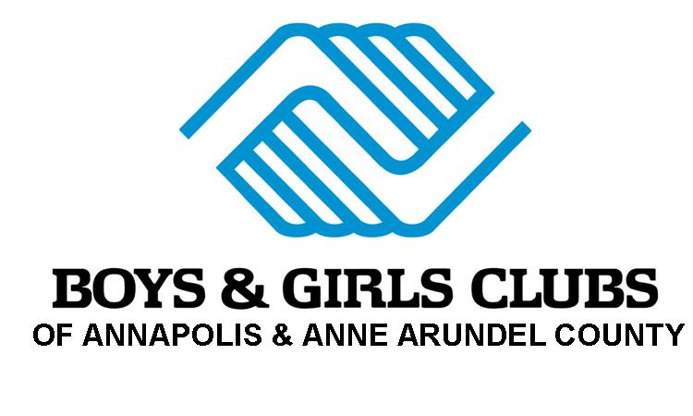
Sizes: Full Page: 5x8" (non bleed) / Half Page Horizontal: 5x3.875"

